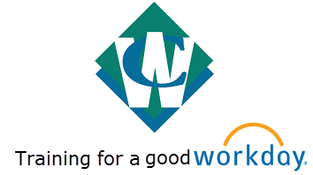

WHAT YOU NEED TO KNOW FROM

WELCOME TO WORKDAY INTRODUCTION TRAINING!

AVAILABLE NOW - TRAINING.WASTECONNECTIONS.COM/WORKDAY

Find SOPs, Instructional Videos/Tutorials, and Job Aides

**NOT YET!!**

AVAILABLE AT GO-LIVE (12/21/16) – new way to contact payroll, benefits and IT for Workday issues during the initial roll out period (approximately go-live thru February)

[WORKDAYHELP@WASTECONNECTIONS.COM](mailto:WORKDAYHELP@WASTECONNECTIONS.COM)